**Prototype**

Justification of prototype

To ensure that the final program I produce is the most efficient and robust I have decided that a prototype will give a large benefit to the project. The idea behind a prototype is to make a mock-up of the final project leaving out little bits of code that won't give a useful benefit but still making sure the program provides the user with their desired needs. For the prototype I will not include dead ends or parts of the code that are repeated elsewhere.

This prototype does give a secondary benefit, once I have created it I can get the opinion of a third party. With their opinion I can then make necessary adjustments when I come to the final program. This will save time as I can do testing prior to finishing the entire code. If I am told there is part of the code that I shouldn’t bring through to the final project, then I can just leave it out not wasting anytime.

Before starting my prototype, I thought to myself which components I will and will not include. I will then tabulate the results to give a clearer viewing of this data.

|  |  |  |
| --- | --- | --- |
| Area of system | Omitted / Included / semi included | Justification |
| Home Screen | Included | All these pages provide links to other pages which have features on them so they are required. |
| Admin page | Included |
| Normal user page | Included |
| Map page | Semi included | The page is included to show how it will be used however I haven’t got the map page to provide live feed of other locker screens yet. |
| Buttons page | Semi included | This page is included and some of the buttons work however I thought it would be a waste of time to code every repeated button on the screen. |
| Page navigation | Included | Without page navigation, there would be no way to access all features, so it is required. |
| Aesthetics on page | Omitted | I will include some images and titles however I do not have an intention on making these looks as best as they could. |
| Login | Semi included | I will make the prototype simulate a login. It will only login to a specific id |
| Scanner | Semi included | I will make it so I am confident the home screen will successfully work with a scanner however I don’t plan on implementing the scanner hardware. |
| System on / off | Included | I will include this as it wouldn’t take much time to program and is a definite feature for the final code. Also, this will show how I can define admin features and normal user features |
| Force unlocking a locker | Included | This again will show how I can separate users and admins and is a key feature of the final program. |
| Normal locker opening | Included |
| Logout | Included | The logout is key for security purposes and needs to show how data isn’t kept on the screen. |
| Adding user | Omitted | This isn’t a necessary feature to show functionality of the program so won’t be included. |

Functionality

Home Screen –

A simple home screen with login

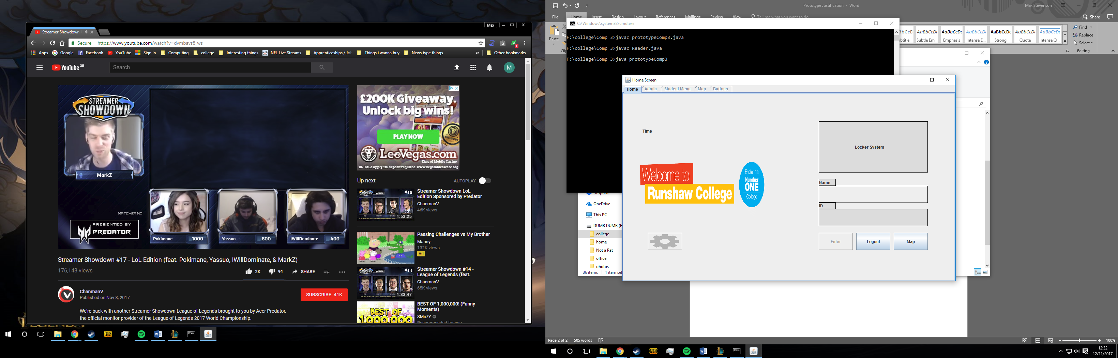

Admin screen –

A basic admin page with admin specific tasks

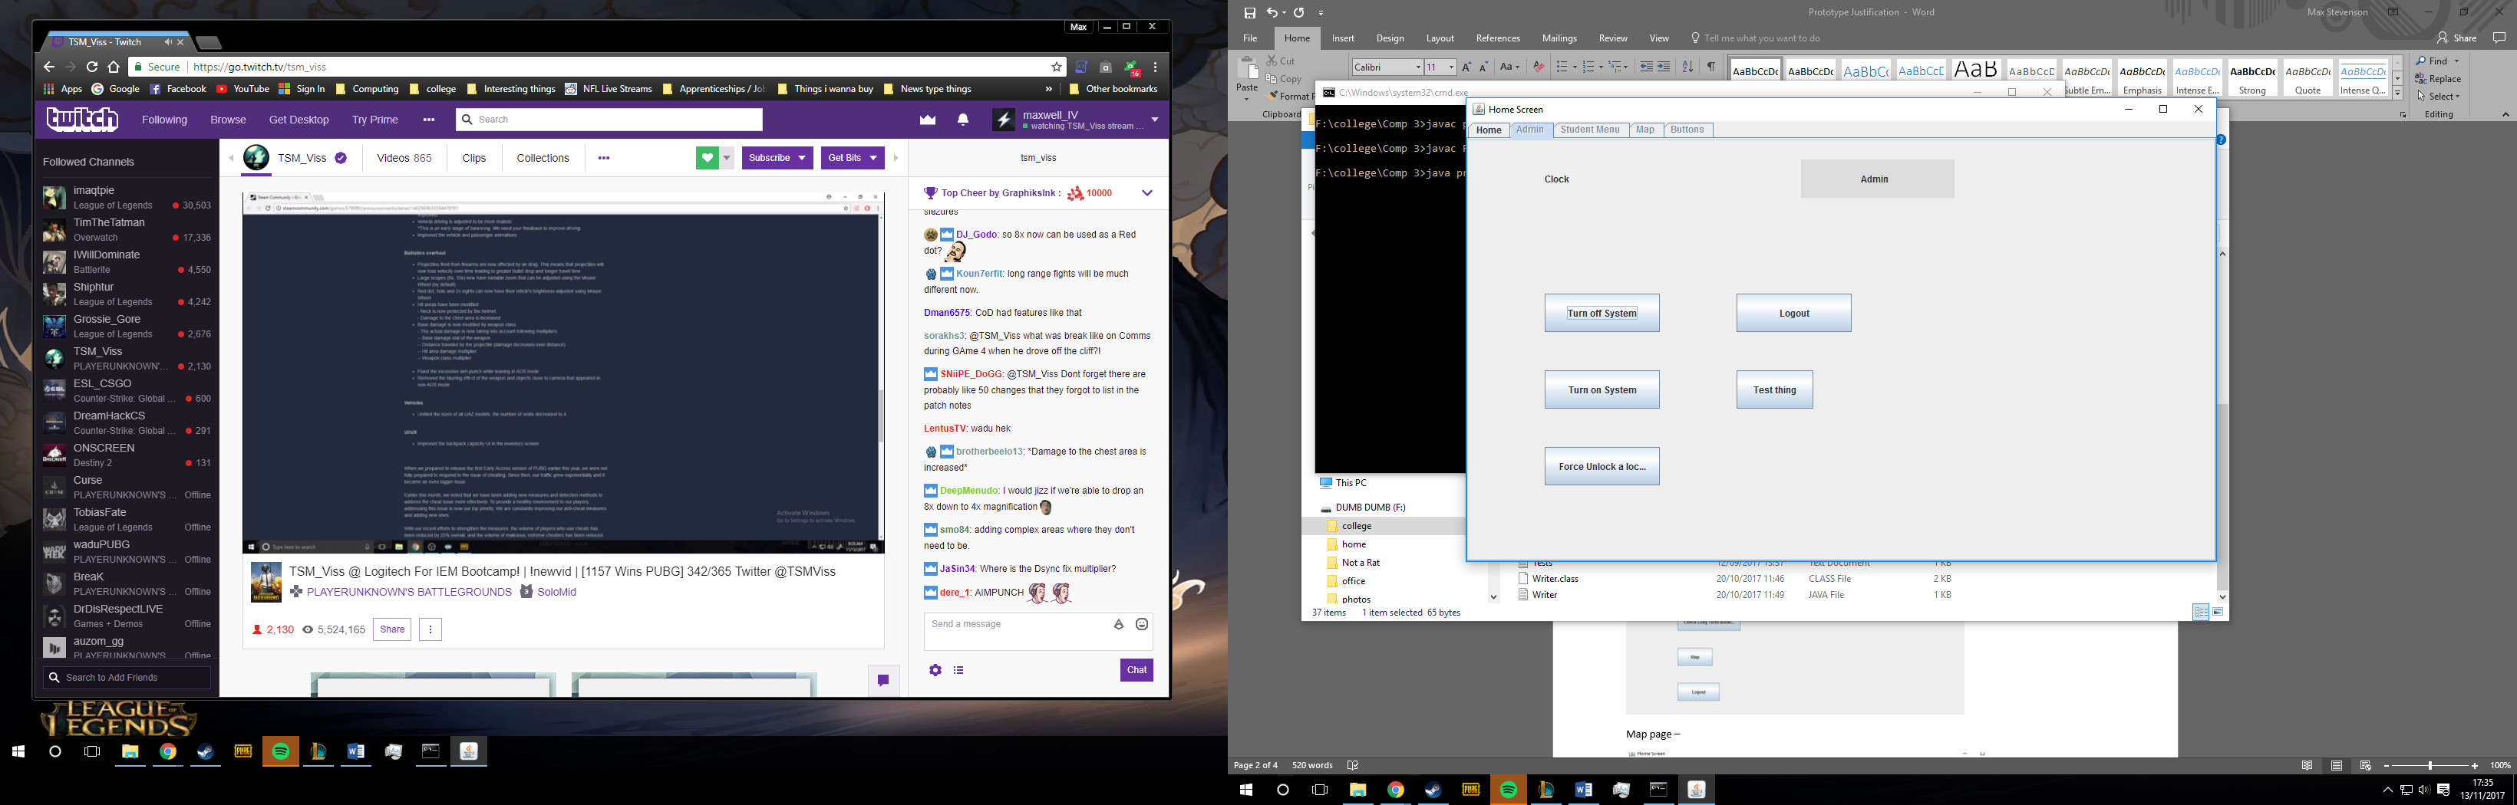

Normal user page –

The normal user page made for people without admin privileges

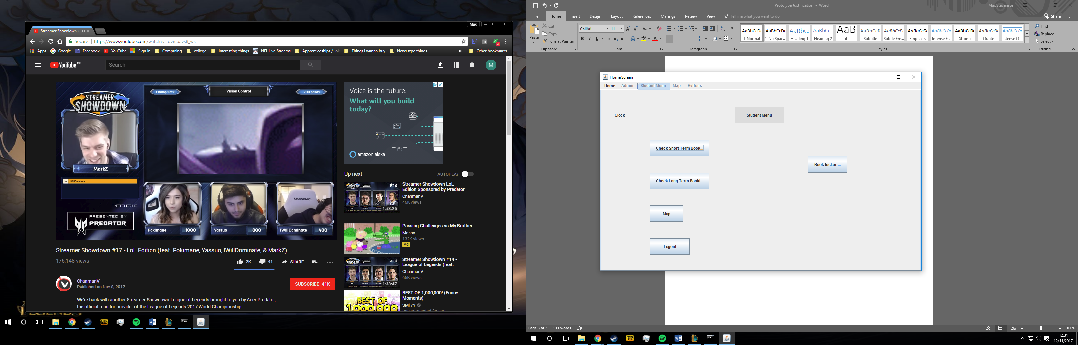

Map page –

A map page showing how the page will look when the final program is created

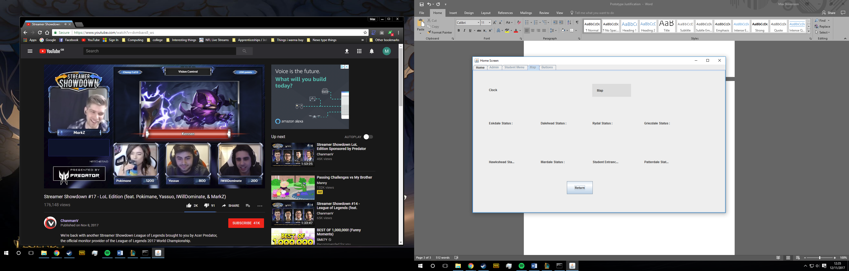

Button page-

A button page showing 5 functional buttons however 21 lockers will work in final code

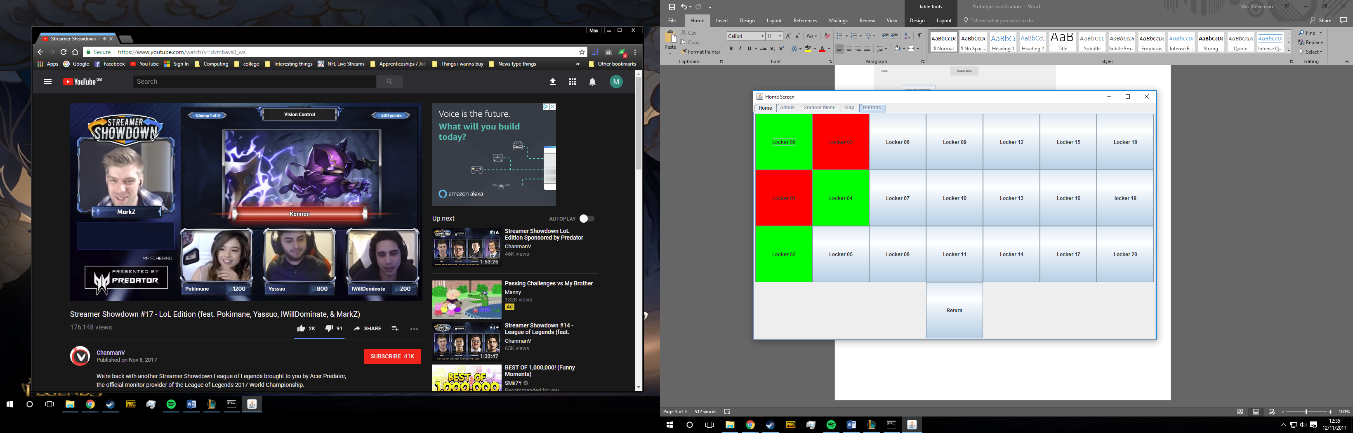

Page navigation-

Page navigation is done by buttons the tabs are designed not to function

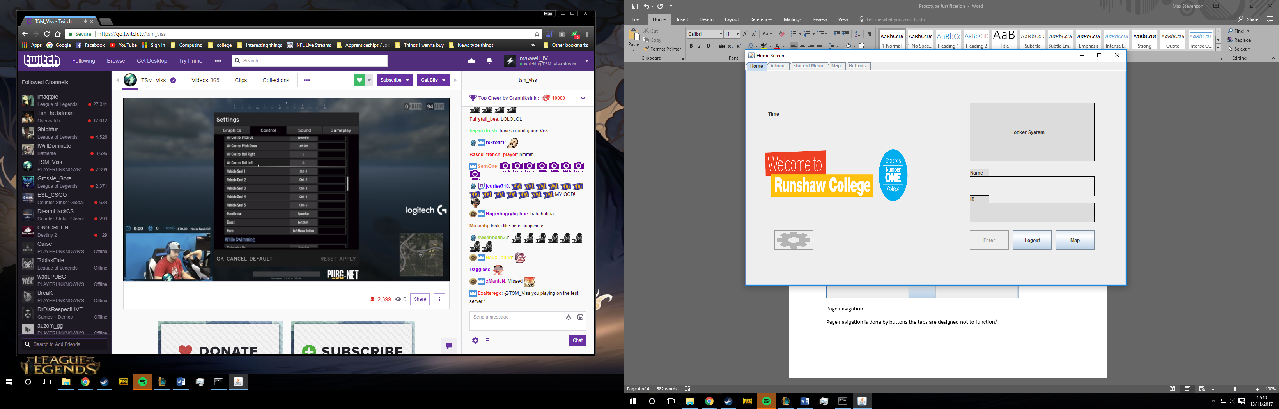

Login-

The login feature is currently only a fixed login showing how it would work when actually designed

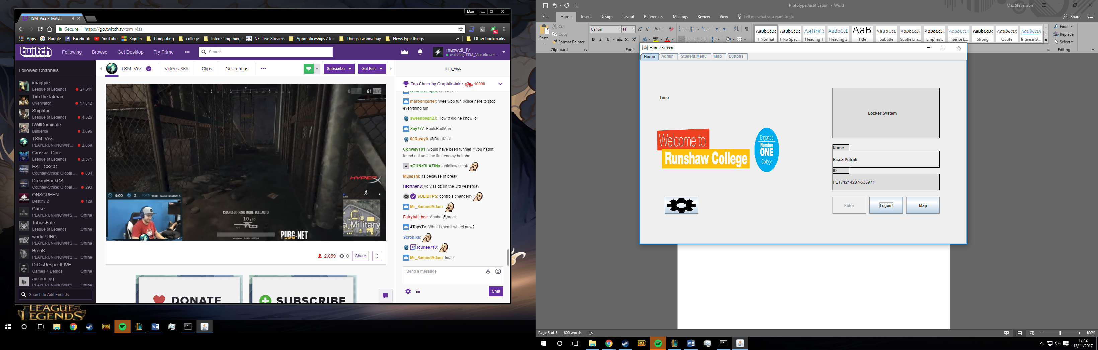

Force opening lockers-

Admins can unlock any locker even if in use. Screenshot shows admin opening locker 03, currently in use.

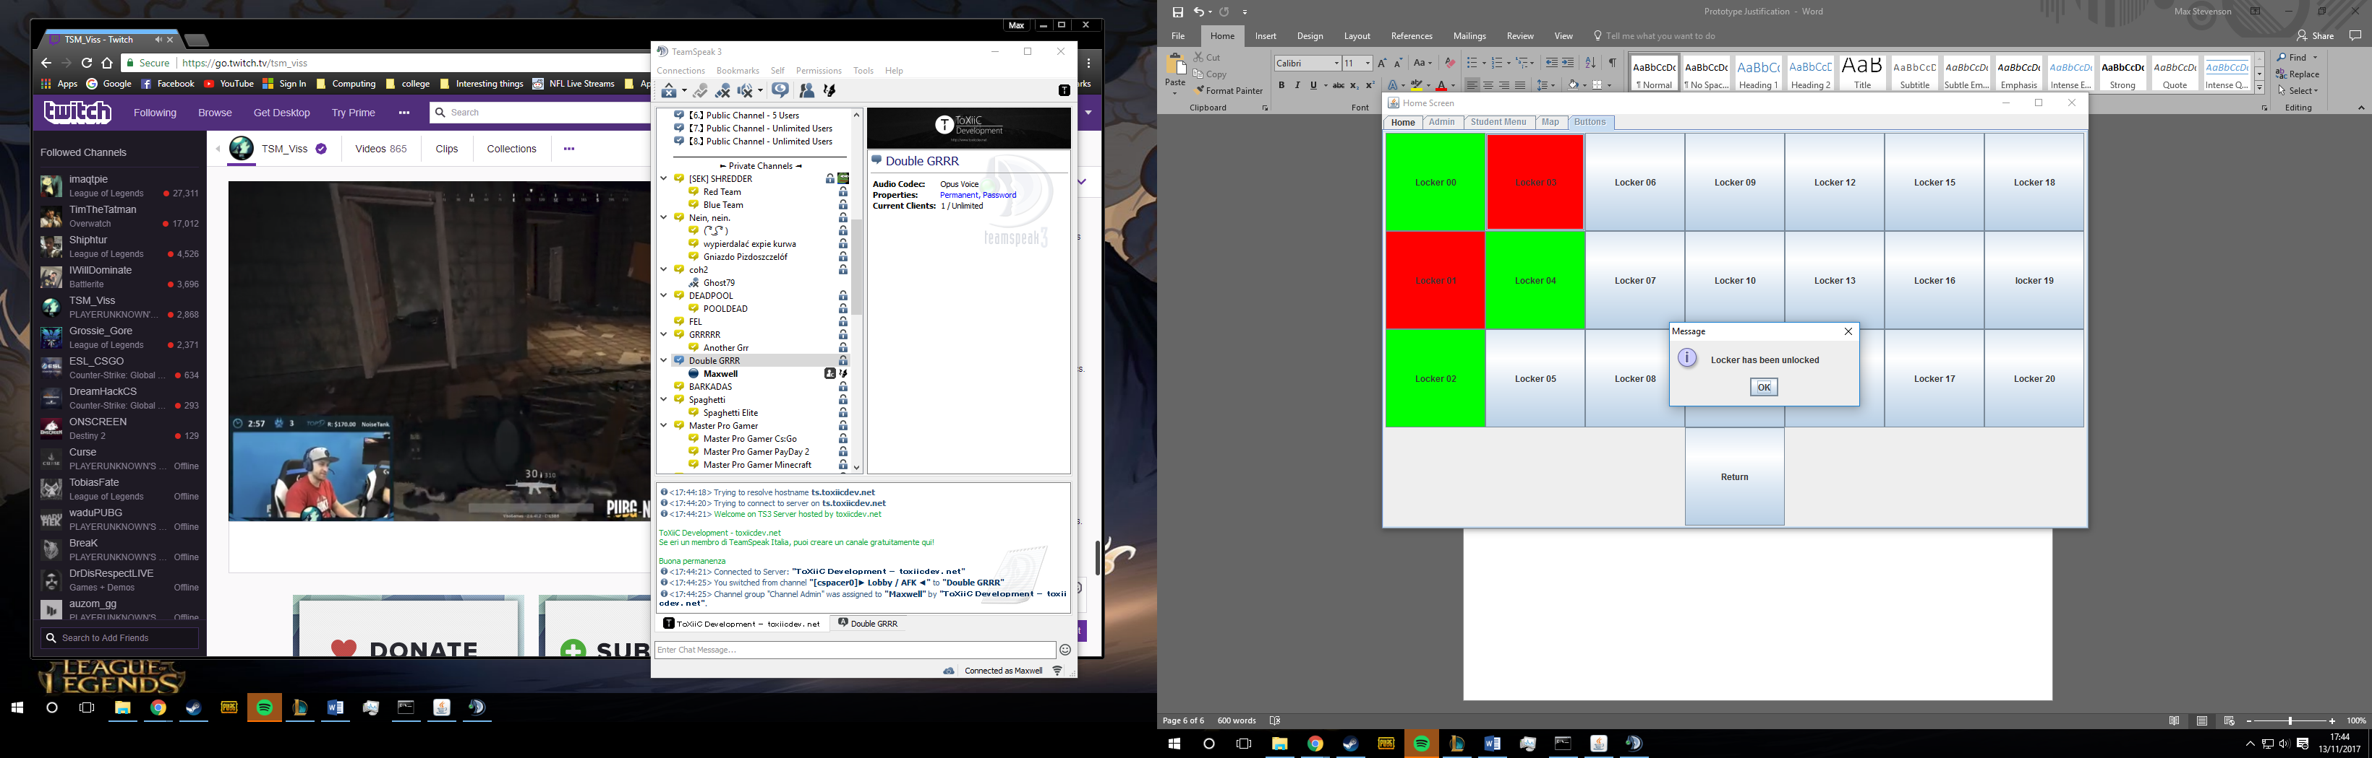

Normal user opening locker-

Normal users can’t open any locker only free ones this screenshot shows a user failing to open locker 03.

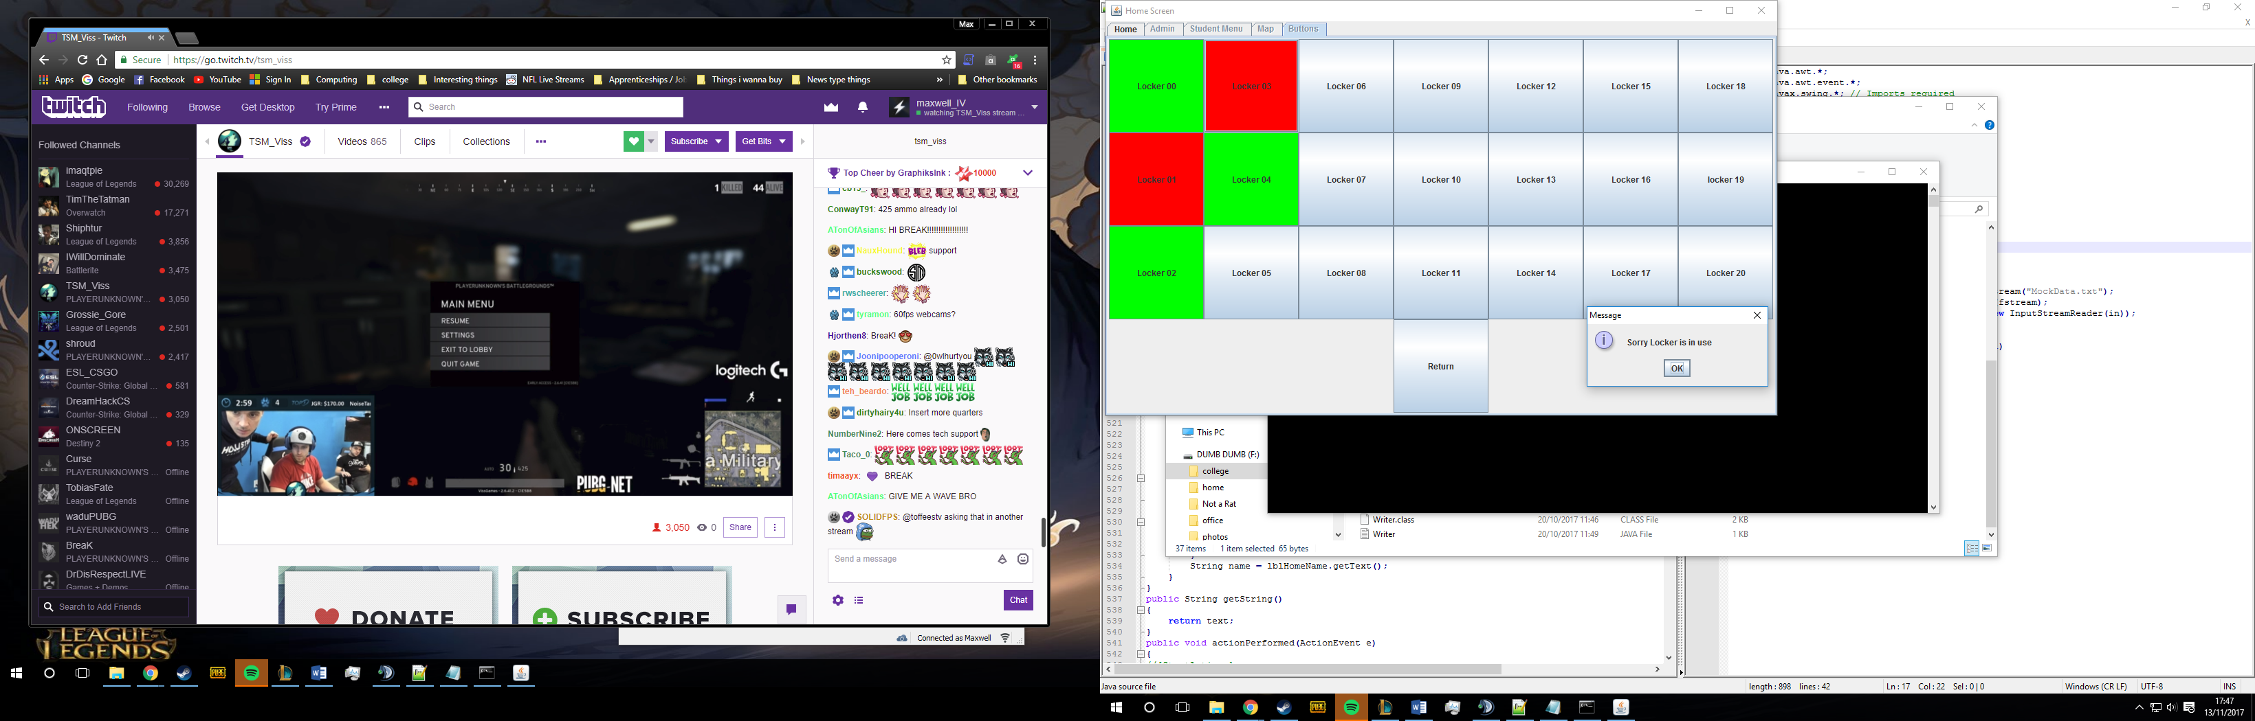

System on / off

Once this button has been clicked a normal user is then unable to enter the system.

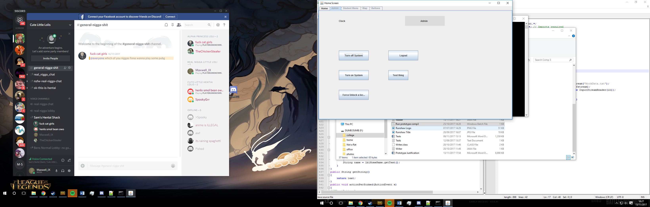

Justification of successful sections of the prototype

|  |  |
| --- | --- |
| Area of system | Explanation of success |
| Home screen | This screen was successful; my program effectively showed how to navigate throughout the system. It wasn’t confusing and wasn’t off putting visually, creating a successful welcome to the system. |
| Admin screen | The admin screen was very basic and had few features, all the features worked and it was clear what was happening. In the final code this will look very different. |
| User screen | This screen shows that the code does differentiate between admins and users. As with the others this screen does produce a simplistic clear way to understand what was happening. |
| Page navigation | This was very successful as all my methods of navigation were functional and I believe it to be clear to the user what takes you to which part of the program. |
| Scanner | Testing the scanner and testing my current system I believe they should both function and give the user the ease of access they need. This has given me confidence that my final code should work fully. |
| Logout | This logout feature is very basic however it does work successfully. |
| Functionality | Looking at the prototype it clearly shows how the system will work and performs all the needed actions. |

Explanation of failures in system

|  |  |
| --- | --- |
| Area of system | Explanation of why it didn’t work |
| Functionality | Although the core features of the system have been included there are several features that weren’t included. |
| Validation | There was very little validation included in the system and this must be improved upon in order to provide a better security. |
| Home screen | The titles are too bland and makes the makes the screen too simple. |